Installing an OS on a Huawei Server by Using Foreman

Install CentOS 7 on a Huawei rack server by using Foreman 1.15.6. The installation steps are as follows.

# Creating an OS Installation Source

## Creating an OS Image Path

The image source supports HTTP and NFS. This document uses HTTP as the source file for OS image installation.

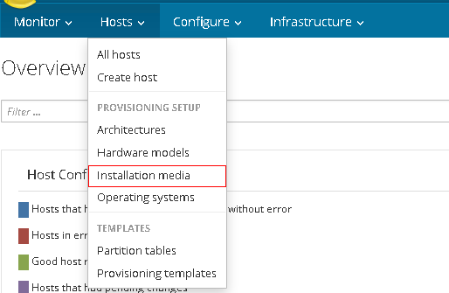

Click **Installation media**, set parameters shown in the following figure, and click **Submit** to save the configuration.

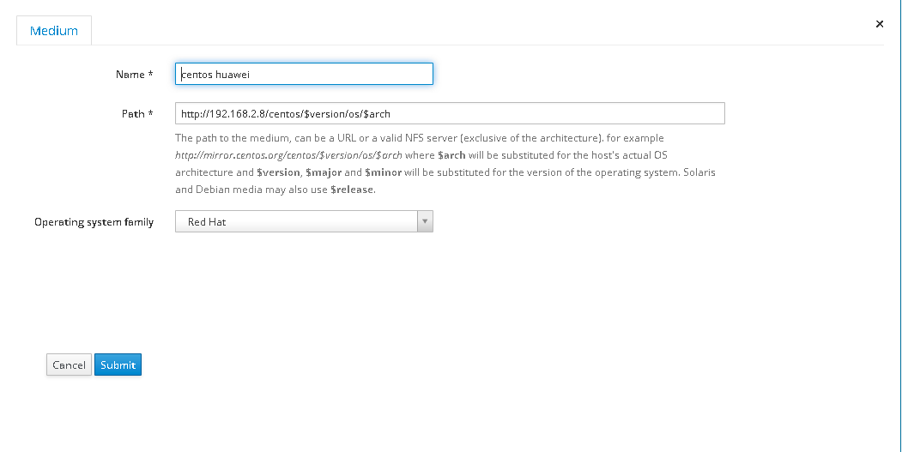

# Creating an OS

## Configuring OS Information

Click **Operating Systems**, as shown in the following figure.

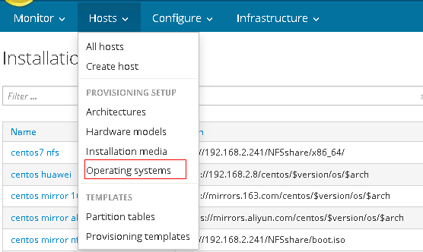

Click **Create Operation System** and enter information on the **Operating System** tab.

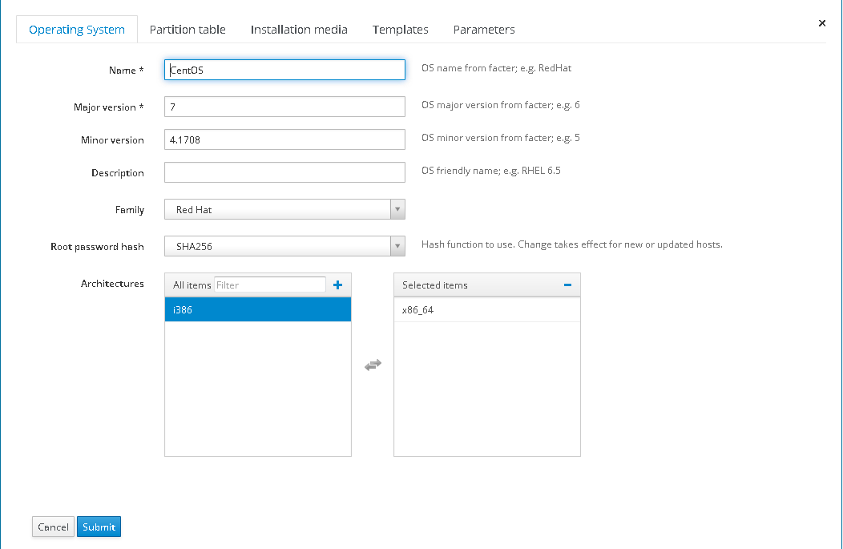

## Configuring a Partition Table

Configure a partition table, as shown in the following figure.

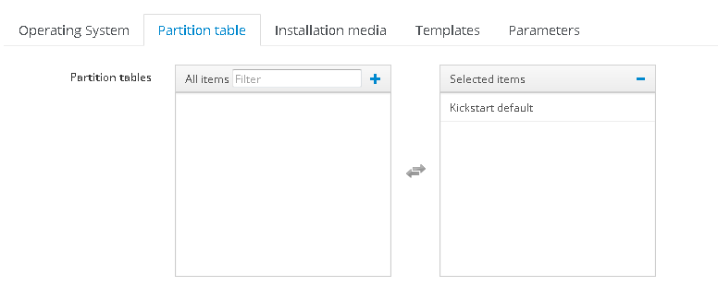

## Configuring Installation Media

Configure installation media, as shown in the following figure.

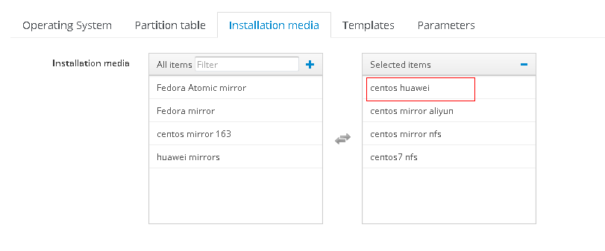

## Configuring Templates

Create templates and click **Provisioning Templates**, as shown in the following figure.

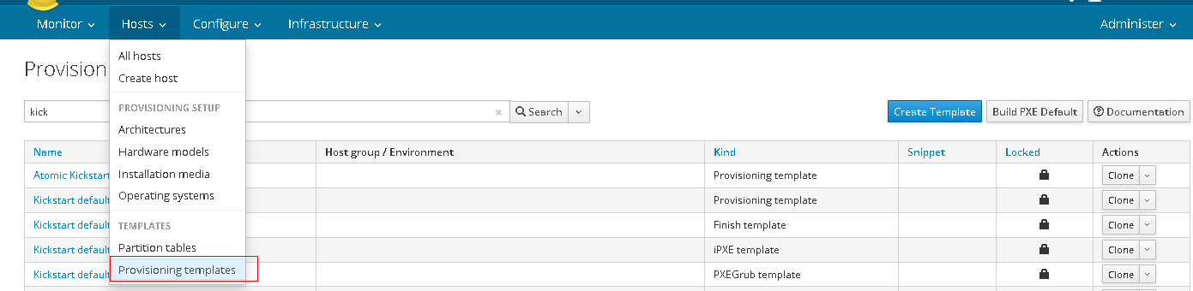

Configure the templates shown in the following figure.

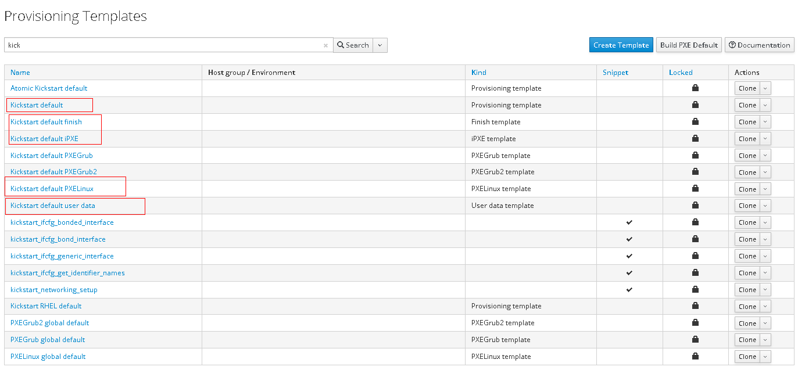

Click a template, click the **Association** tab, and select the OS name, as shown in the following figure.

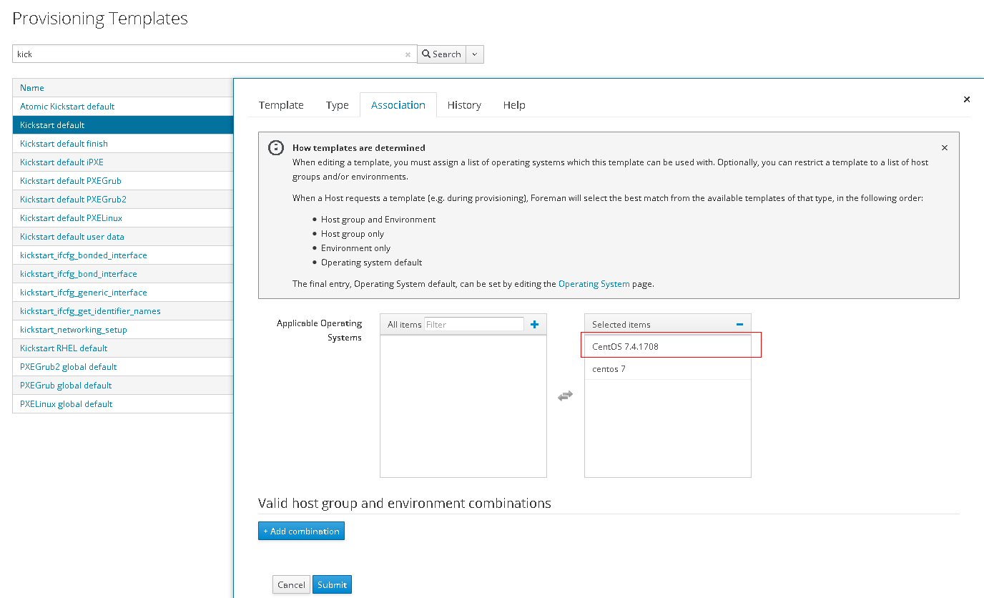

After all templates are configured, return to the **Operating System** window, and configure template types, as shown in the following figure.

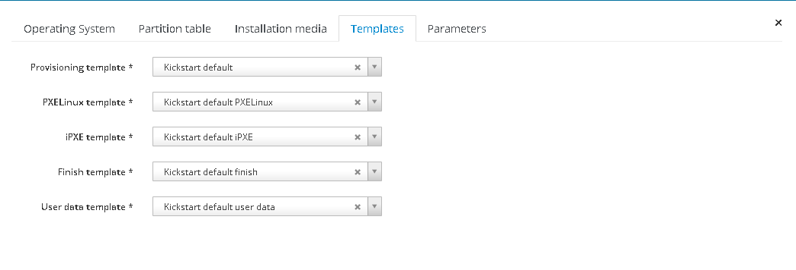

Save and submit the configuration. The information about the OS is displayed as follows.

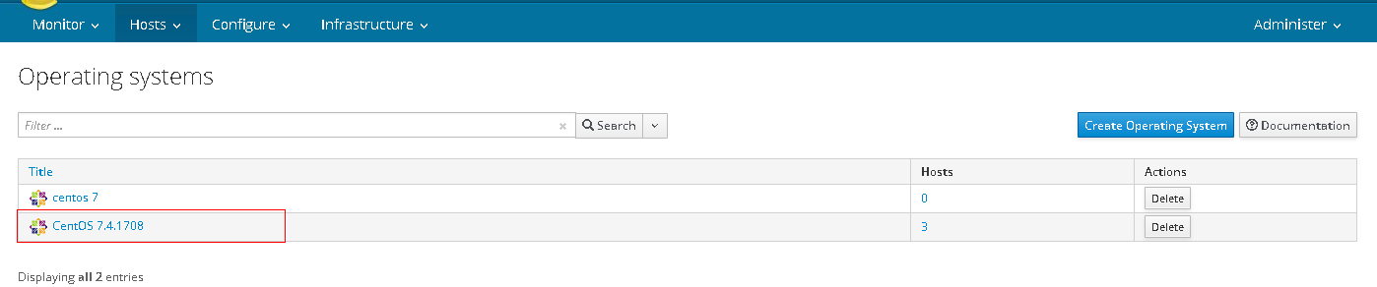

# Configuring an OS

Choose **Infrastructure > Provisioning setup**.

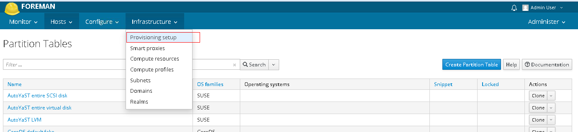

## Configuring the Network

Select a network.

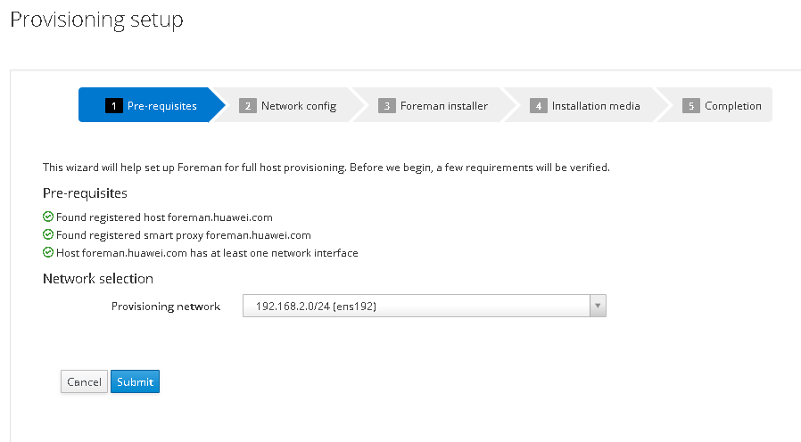

Configure network information, as shown in the following figure.

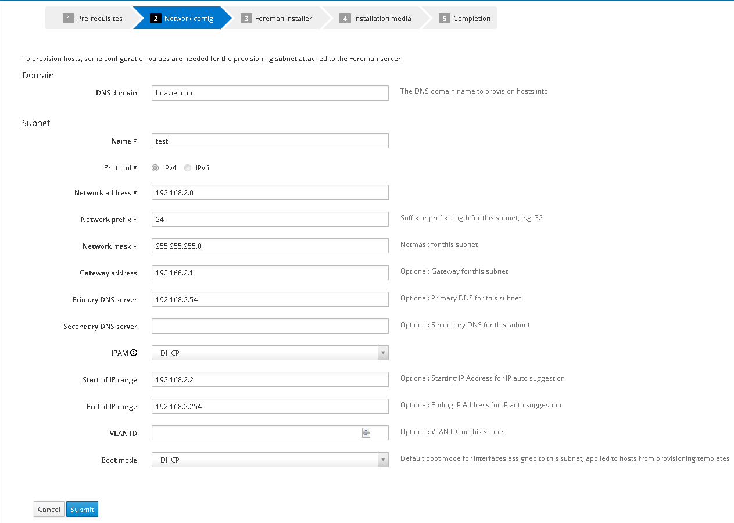

## Running the Foreman Installer

Copy the commands of the required installation mode, and run the commands on the Foreman server.

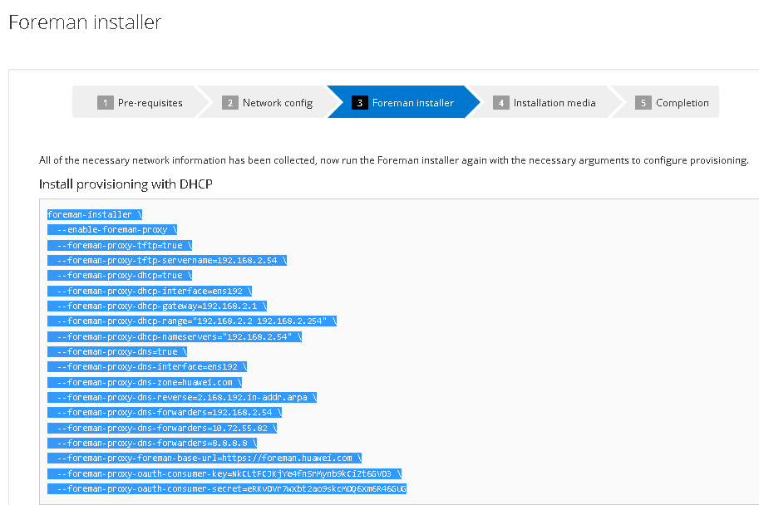

The execution results are as follows.

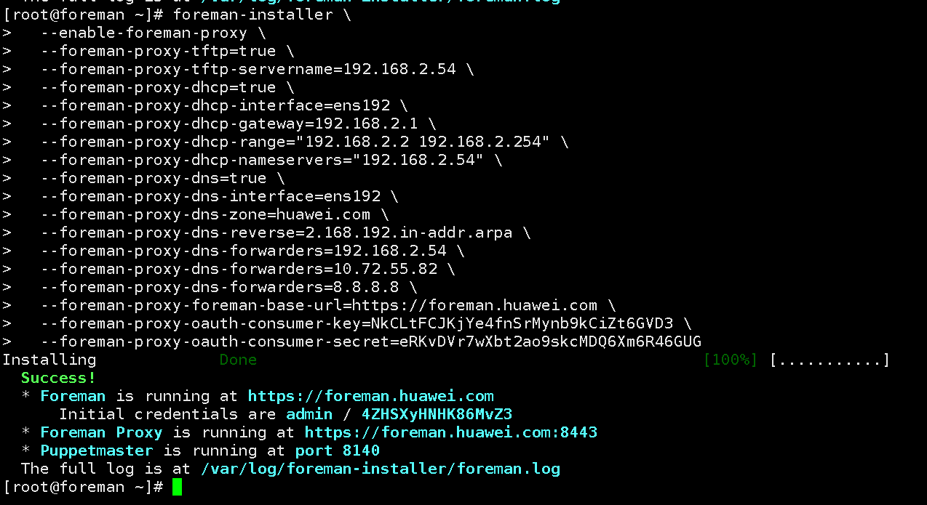

## Configuring Installation Media

Select installation media, as shown in the following figure.

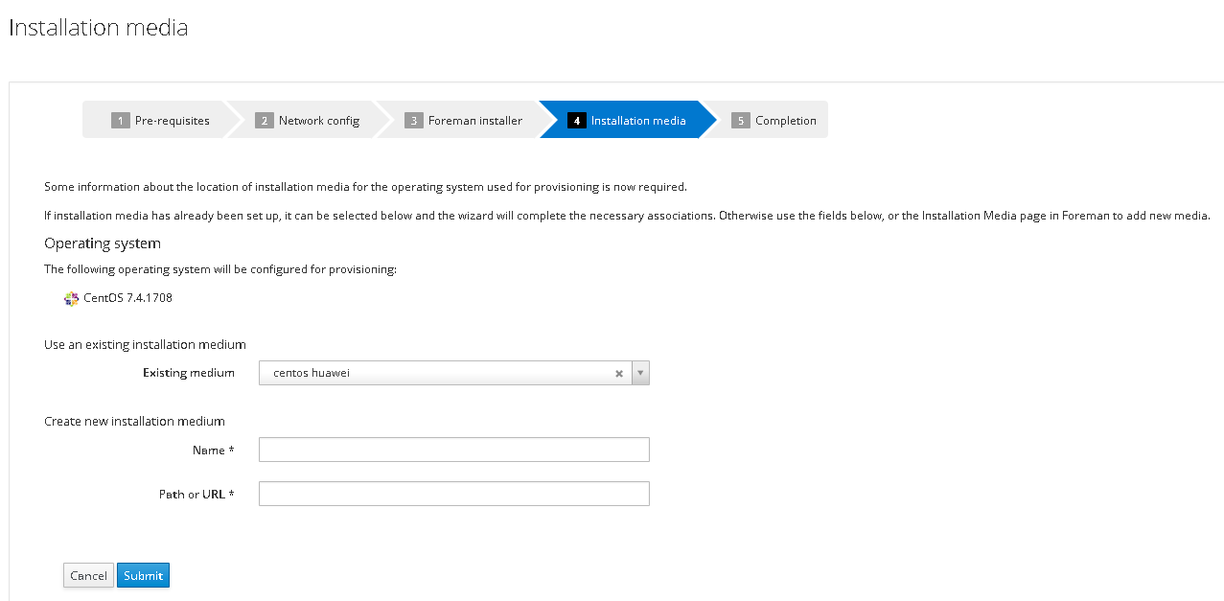

## Creating a Host

Click **New Host** and create an installation object.

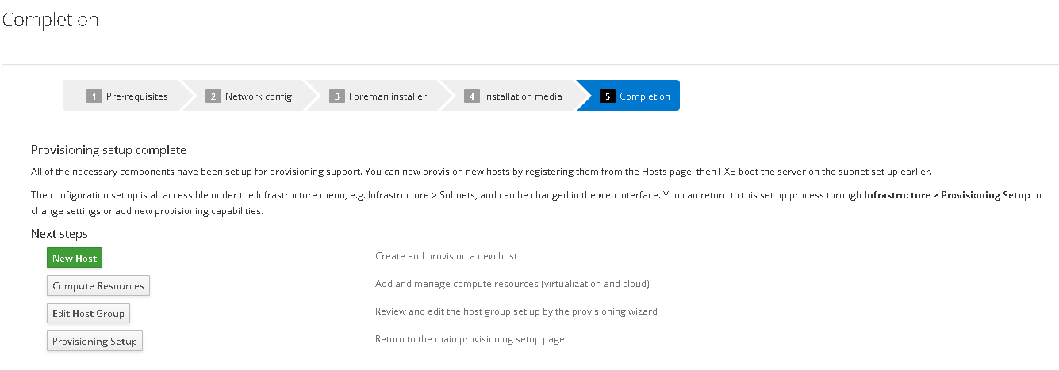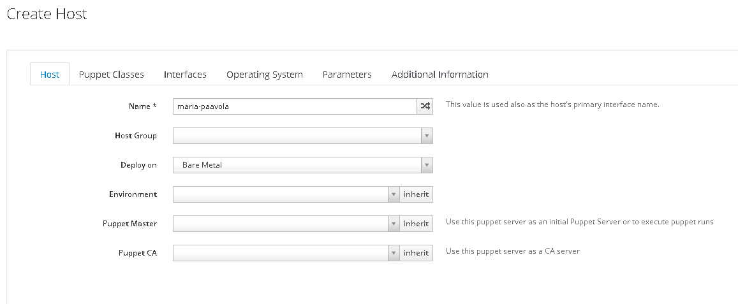

## Configuring Interface Information

Click **Edit** to configure network interface information.

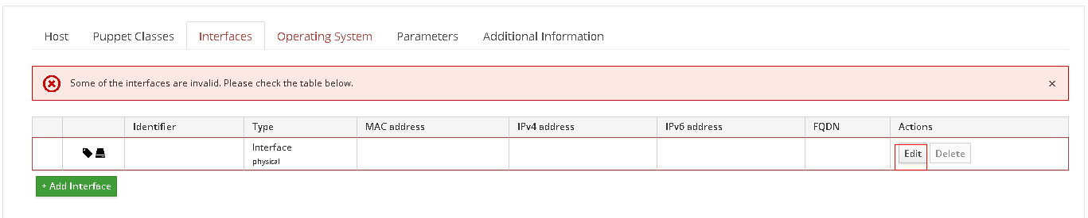

Configure the MAC address of the server where an OS is to be installed and the IP address allocated by the DHCP server, as shown in the following figure.

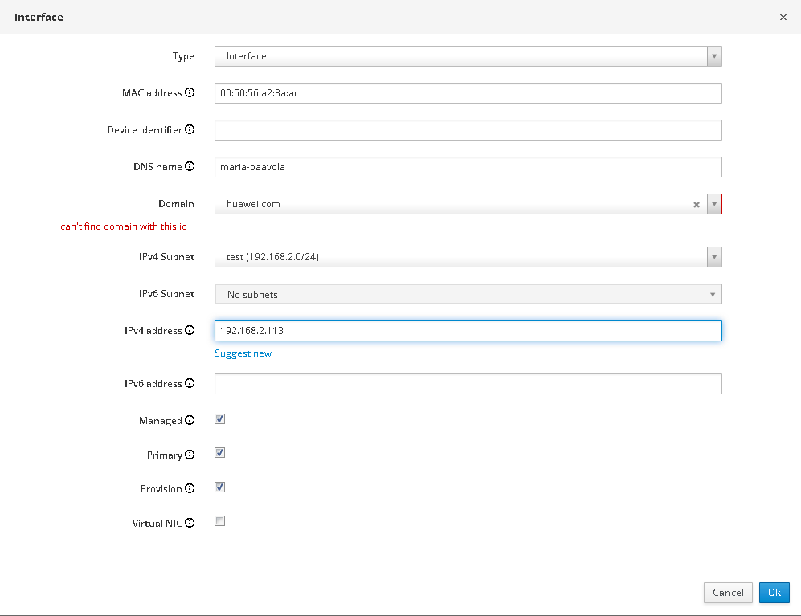

Note that the MAC address is the MAC address of the service network port on the server.

## Configuring OS Information

Configure information of the OS to be installed.

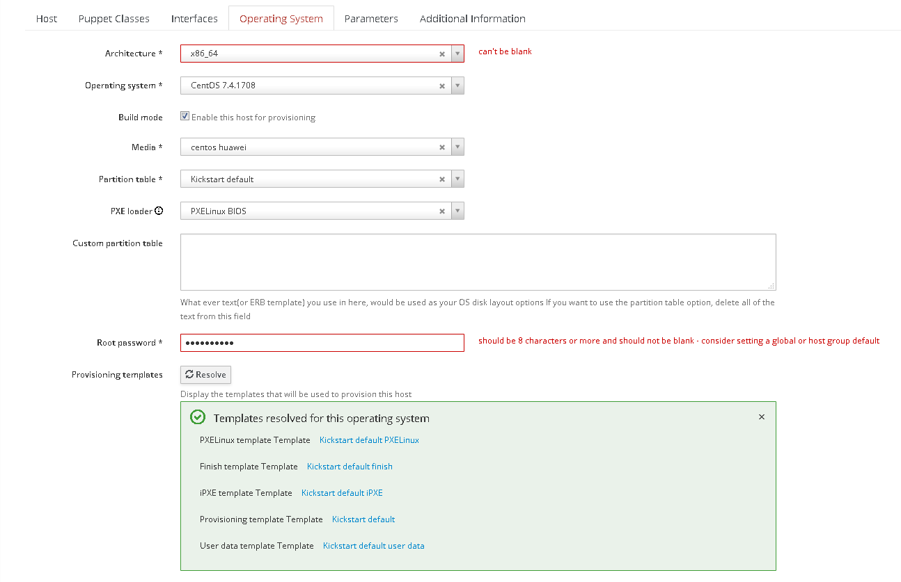

After the configuration is complete, the information is displayed as follows.

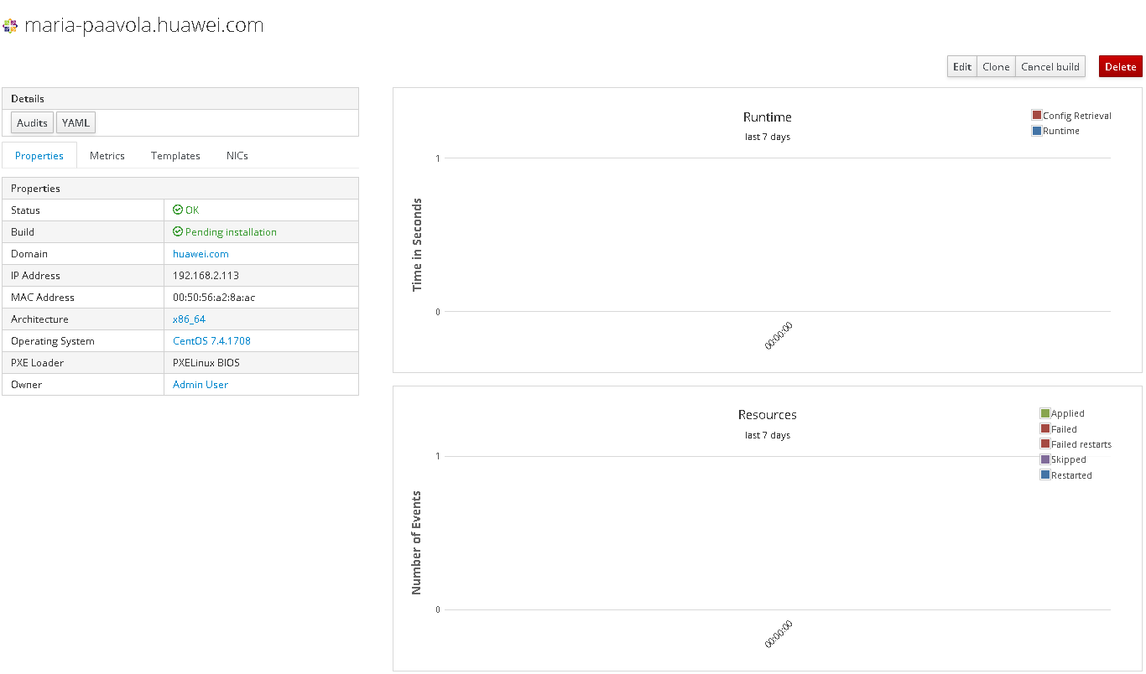

# Installing an OS

## Configuring the PXE Boot Mode

Access the BMC page of the server where an OS is to be installed and choose **Configuration** > **Boot Device**.

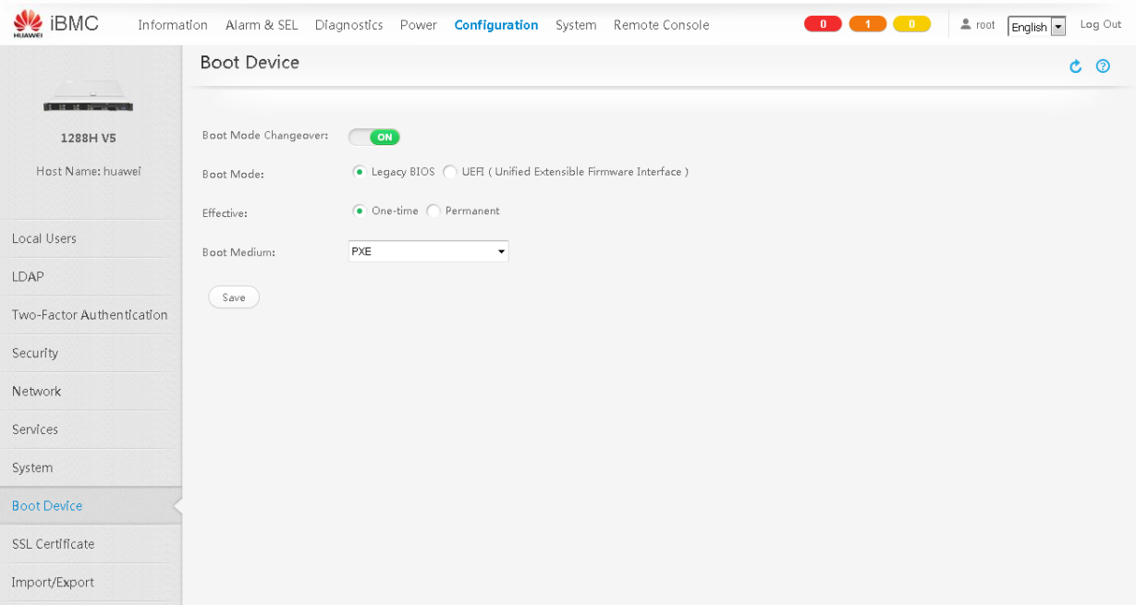

Configure the server where an OS is to be installed to boot from PXE.

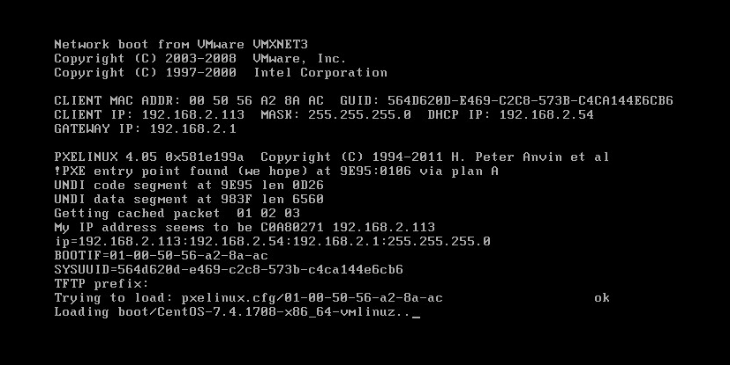

Load the boot file.

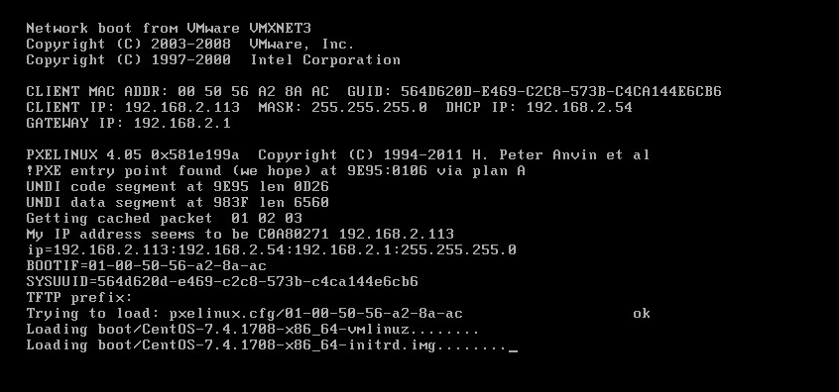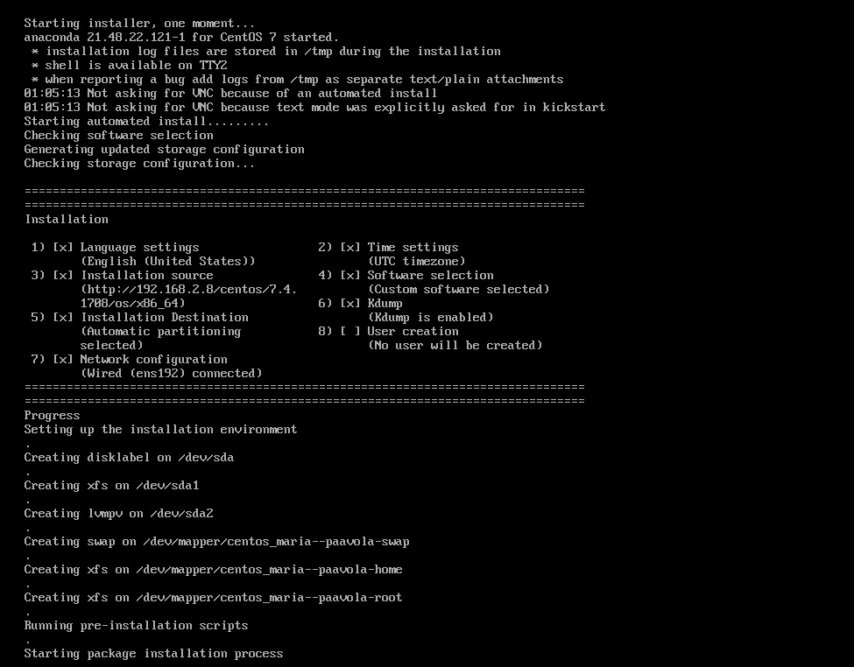

The installation starts.

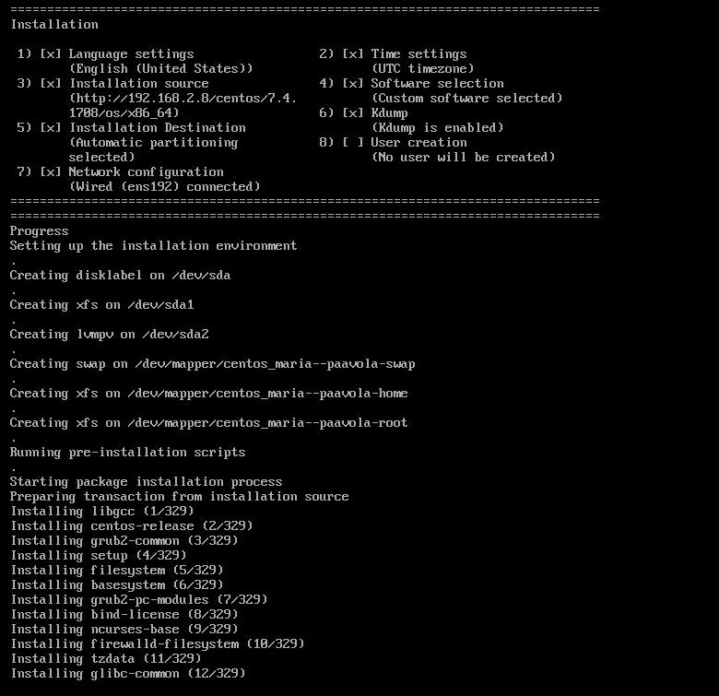

The installation is successful.

